 Parks and Recreation Sponsorships 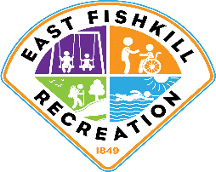

Organization/Company Name:______________________________________________________

Contact Person:_______________________ Phone ______________ Email: _________________

Address: _______________________________________________________________________

Make checks payable to the Town of East Fishkill.Return **check, completed form(s), and ad copy to:**

Town of East Fishkill Recreation, 5 Old Lime Kiln Rd., Hopewell Junction, NY 12533

via email: [Recreation1@eastfishkillny.org](mailto:Recreation1@eastfishkillny.org)

□ **2020** **Recreation Guide** (January 2020 – December 2020) Booklet Size 8.5 x 5.5, Color

**The Recreation Guide is distributed annually to 6,000 local residents**

APPLICATION DEADLINE FOR THE 2020 RECREATION GUIDE IS DECEMBER 01, 2019

□ Full Page $400

□ 1/2 Page $200

□ Business Card $100

□ **2020 Community Day** **Sponsorship** – September 12, 2020. Booklet size 8.5 x 5.5, Black & White

□ Full Page $90

□ Half Page $65

□ **2020 Field Banner Sponsorship** (April 2020 – November 2020)

Display your company banner in our parks and ballfields

**\* Banner Sponsorship must include completed Form EFR-114A attached**

□ $250

**Triple Play**

**Sponsor All Three above and receive a special rate for Full Page ads and Banner**

□ $650 (a savings of $90) Recreation Guide, Community Day Program, Field Banner

□ **2020 Website Sponsor** (January 2020 – December 2020)

Your company logo and website link on each of our website pages

□ $5,000

**See our website for more details** [**www.eastfishkillrecreation.com**](http://www.eastfishkillrecreation.com)

Form EFR-115.2020