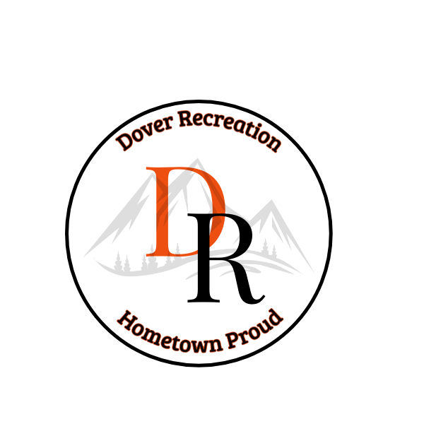
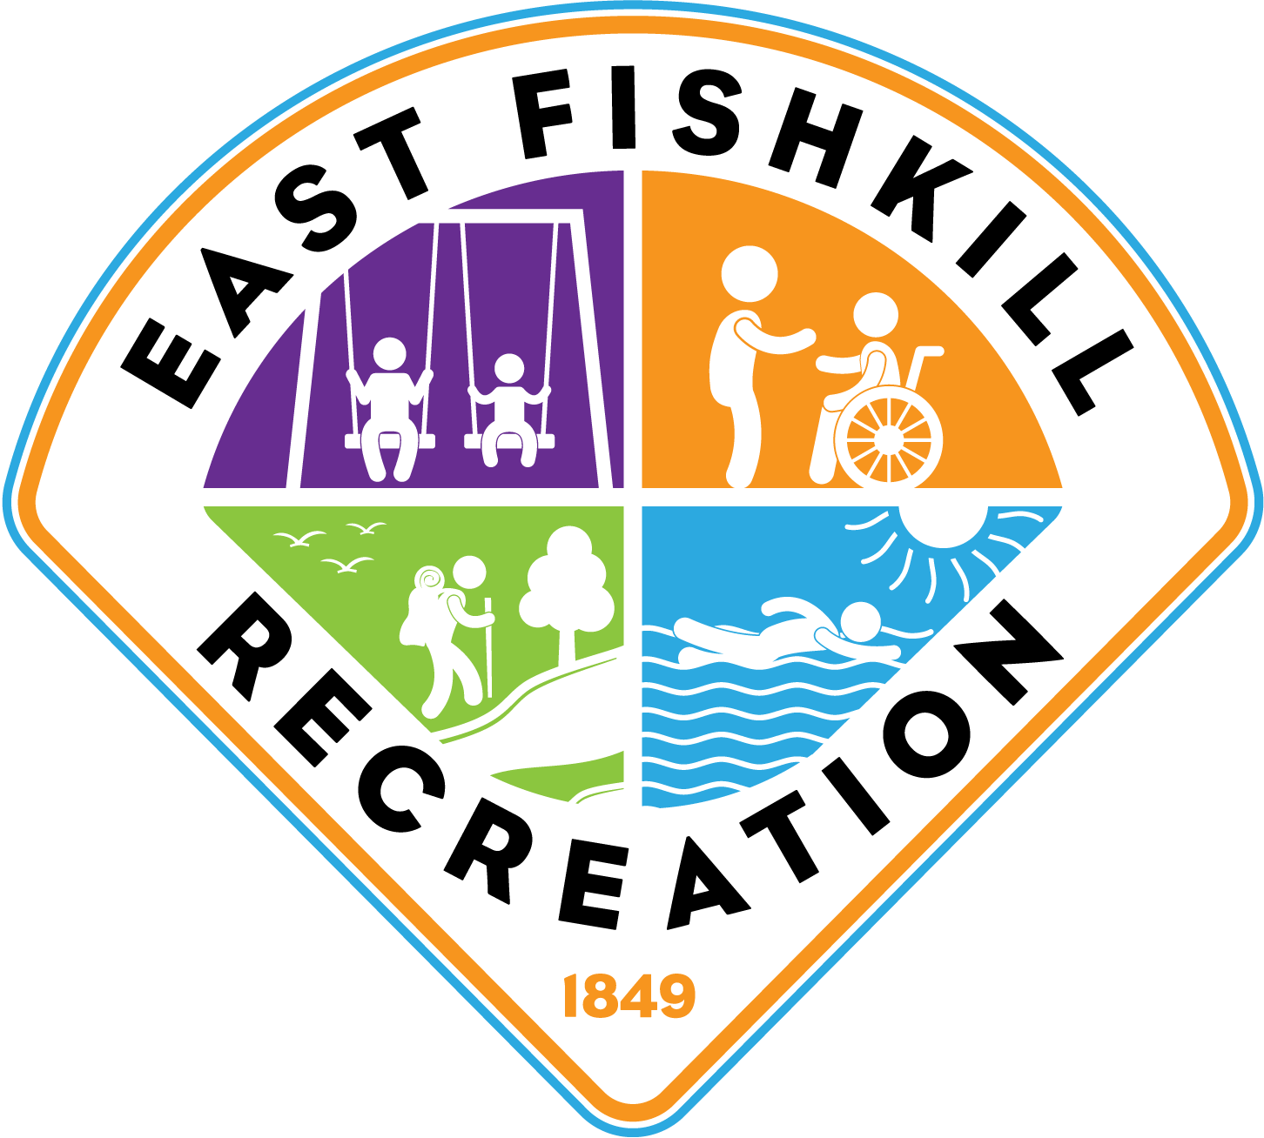

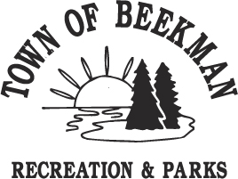
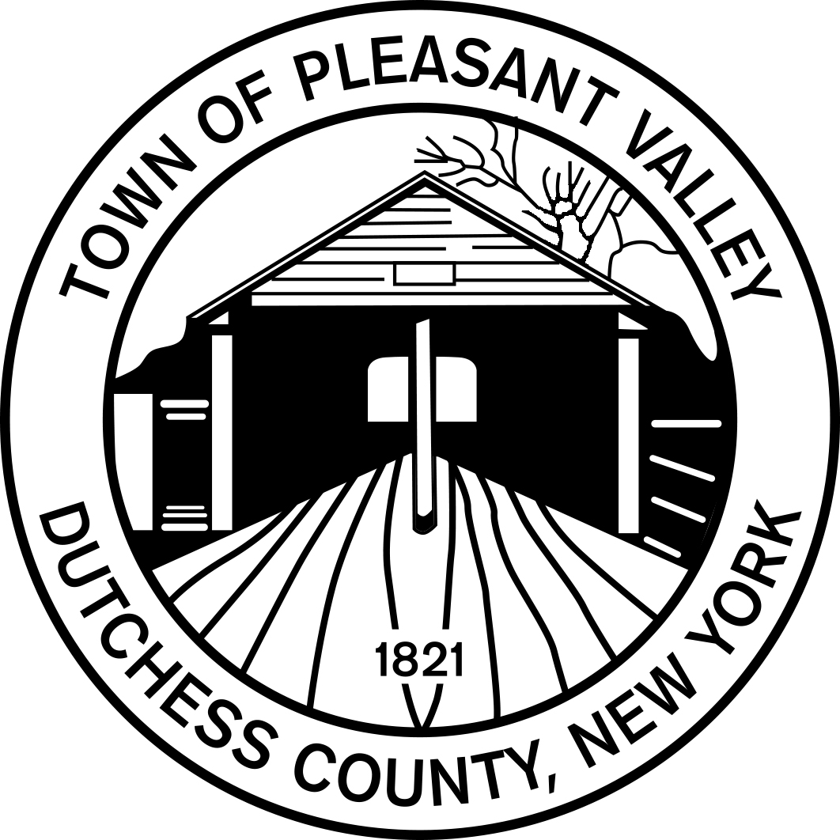

Inter-Town, Co-ed, Adult, 6-on-6, Beach Volleyball

WHERE: Recreation Park in Beekman, Boyce Park in Dover, Lakeside Park in Pawling, Hopewell Recreation Park in Hopewell, Helen Aldrich Park in Salt Point
WHEN: June 28th to August 16th
Wednesday Evening games begin at 6:30pm
Thursday Evening Make-up games begin 6:30pm
WHO: Adults Ages 18+

What to expect:
This league was established for adults to gather for friendly 6 on 6 sand volleyball competitions. This is not an aggressive or overly competitive league. All Playing abilities are welcome to join. Games will take place at local parks in our area. At the end of the regular season, there will be a play-off tournament tail-gate pot-luck picnic at East Fishskill Recreation. The winning play-off team will have their team name engraved on the League’s “Mattes Cup” trophy to be displayed in their local Parks and Recreation Department until next year’s tournament.

Rules:
For a complete set of rules, download from your Town’s website on the Volleyball program page or visit your local Recreation Office for a paper copy.

Fees:
$30 resident, $40 non-resident (please pay according to your Town’s payment procedures
Each team will be provided one ball for season

Two ways to register
1. Players may register as a “Free Agent” and be placed on a team that is looking for more players.
2. Players may register as a team. Teams must have at least 2 male and 2 female participant in order to play.

Complete registration form (available on website)

